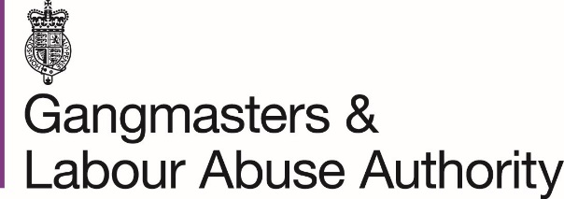

GLAA communications
If you would like any of the products listed below please return the form with the quantities required to communications@gla.gov.uk, or download the online versions at www.gla.gov.uk/publications/resources.

Workers’ rights leaflet
 |  | Albanian |  | Hungarian |  | Romanian
 |  | Bengali |  | Kurdish |  | Russian
 |  | Bulgarian |  | Latvian |  | Slovak
 |  | Chinese |  | Lithuanian |  | Ukrainian
 |  | Czech |  | Nepali |  | Urdu
 |  | English |  | Polish |  | Vietnamese
 |  | Gujarati |  | Portuguese |  | Welsh
 |  | Hindi |  | Punjabi
Know your rights poster
 | Language | Sector | Quantity
Know the signs poster
 | Language | Sector | Quantity
Know your rights and Know the signs posters are available in the following languages:
Albanian, Bengali, Bulgarian, Chinese, Czech, English, Gujarati, Hindi, Hungarian, Kurdish, Latvian, Lithuanian, Polish, Portuguese, Punjabi, Romanian, Russian, Spanish, Slovak, Ukrainian, Urdu, Vietnamese, Welsh.
And the following sectors:
Agriculture, catering, car wash, cleaning, construction, food retail, health / care, horticulture, manufacturing, nail bar, packing, shellfish gathering, textiles, warehouse, young workers / students.

Workers’ checklist poster
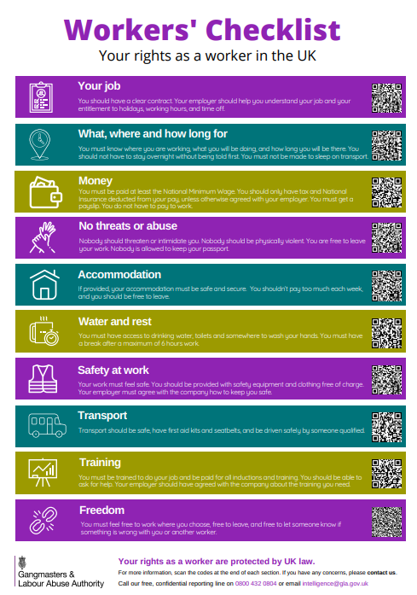 |  |  | Bulgarian
 |  |  | English
 |  |  | Polish
 |  |  | Romanian
 |  |  | Ukrainian
Labour exploitation is a crime poster
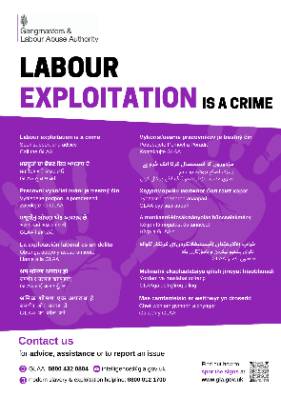 |  | Poster 1 - English, Albanian, Chinese, Portuguese, Bengali, Vietnamese, Ukrainian, Bulgarian, Polish, Latvian, Russian, Romanian, Lithuanian, Welsh
 |  | Poster 2 - English, Punjabi, Nepali, Gujarati, Hindi, Czech, Spanish, Slovak, Urdu, Mongolian, Hungarian, Kurdish, Uzbek, Welsh
Spot the signs leaflet
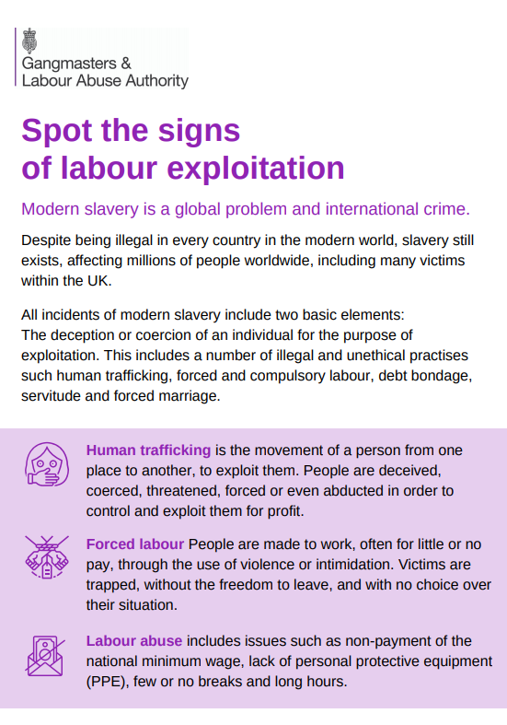 |  | English
 |  | Nepali

