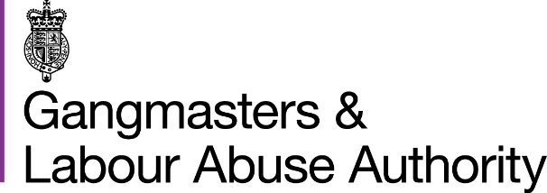

Guaranteed Interview Scheme (GIS) form

We are an Equal Opportunities employer and we welcome applications from people with disabilities.
The Authority is committed to the employment and career development of people with disabilities. Applicants with disabilities meeting the minimum criteria for the post will automatically go forward to the final stage of the selection process without further testing.
From 1 October 2010, the Equality Act replaced most of the Disability Discrimination Act (DDA). However, the Disability Equality Duty in the DDA continues to apply.
The DDA definition: “A physical or mental impairment which has substantial and long-term adverse effect on a person’s ability to carry out normal day to day activities”.

Impairment
The definition requires that the effects that an individual may experience arise from a physical or mental impairment. Physical impairment includes sensory impairments, such as those that affect sight or hearing. Mental impairment includes a range of recognised impairments relating to mental functioning, including what are often known as learning disabilities and other clinically recognised mental illness.

Long-term
This means an effect which:
- Has lasted twelve months;
- Is likely to last for a period of at least twelve months;
- Is likely to last for the rest of the individual’s life.

Substantial adverse effect
This means that the disability must be more than trivial or minor. Recurring conditions are included such as Multiple Sclerosis and Epilepsy. Severe disfigurement is also covered.

Normal day-to-day activities
The Act says that there is only an effect on a person’s ability to carry out normal day to day activities if the impairment affects any of the following:
- Mobility;
- Manual dexterity;
- Speech, hearing or sight;
- Physical co-ordination;
- Continence;
- Ability to lift, carry or move everyday objects;
- Memory or the ability to concentrate, learn or understand; or
- Perception of the risk of physical danger.

Certain conditions are specifically excluded from the coverage of the Act. These include:

- Addiction to or dependency on alcohol, nicotine or any other substance (other than as a result of the substance being medically prescribed);
- Seasonal allergic rhinitis (such as hay fever) except where it aggravates the effect of another condition;
- Tendency to set fires;
- Tendency to steal;
- Tendency to physical or sexual abuse of other persons;
- Exhibitionism; or
- Voyeurism.

Disfigurements that consist of a tattoo (which has not been removed), non-metal body piercing, or something attached through such piercing, are treated as not having substantial adverse effect on the person’s ability to carry out normal day-to-day activities.
ASSISTANCE FOR INTERVIEW
To ensure we do not create any barriers in our selection process and to help us implement our equal opportunities policy effectively, please let us know if you would like us to provide any particular assistance for your interview, such as:
Please Tick
Induction loop
Sign language interpreter (type)
Keyboard for written tests
Someone with you at the interview (e.g. speech facilitator)
Car parking
Assistance in and out of the vehicle
Wheel chair access
Accessible toilet facilities
Other assistance (please specify)
If you have any questions about your specific needs at interview or would like to give us more information, please contact the GLAA’s HR Department by email on hr@gla.gov.uk or by phone on 0115 959 7078.

DECLARATION
I consider myself to have a disability as defined on the previous page and I would like to apply under the Guaranteed Interview Scheme.
Any false declaration of disability to obtain an interview will cause your application to be terminated, or will invalidate your contract of employment.

APPLICANT NAME:
APPLICANT SIGNATURE:
DATE:

